US History 2 Course Syllabus
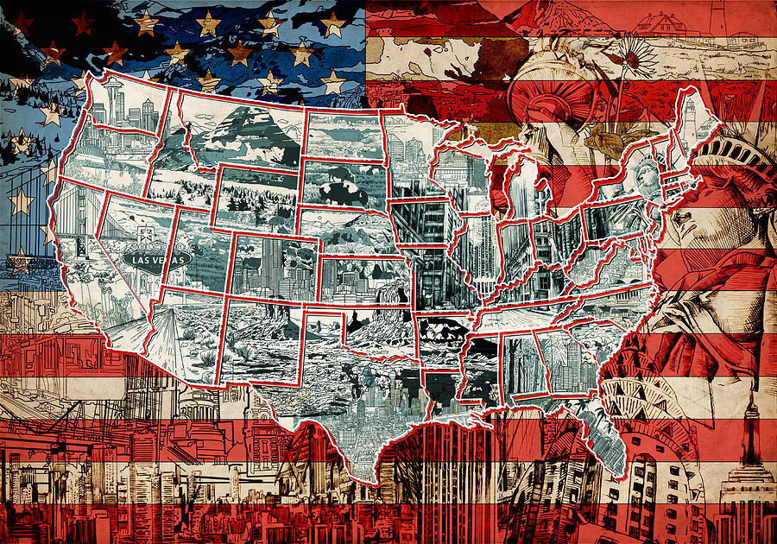
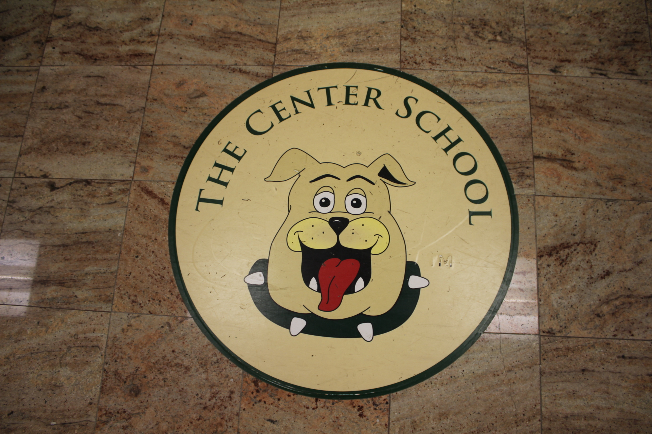

Teacher: Mr. Miller
School Year: 2019-20
Grade: 11/12
Student Name:

Course Description:
-Welcome to what promises to be an exciting and successful 2019-20 school year. I am eagerly looking forward to a year of true learning, growth, and empowerment. The US History 2 class is a broad survey of events, people, and places that have significantly influenced human development in the United States for approximately the past 150 years. Students can be expected to analyze political and economic philosophies, examine primary and secondary sources from various time periods, and view many places in the United States that hosted many historical moments. Students will also gain insight on some of the more recent events from history that have helped to shape our land into the country that it is today.

Course Text:
-As a supplemental resource, students will be using the McGraw-Hill United States History and Geography text for assignments and projects.

Academic Expectations/Grading:
Each student is expected to arrive to class each day prepared for class activities and ready to be a productive member of the classroom. If a student is absent from class due to an absence from school, meeting with counselor, nurse visit, speech and language, etc. it is their responsibility to obtain any work that was missed during that class period and to record any homework assignments.

Each student will be assessed on a daily basis using a variety of assessment tools and strategies. The following is a list of categories, assessment examples included in the category, and the percent that each category counts towards a student’s final grade.

Quizzes/Tests-reading quizzes; chapter tests: 15%

Homework-Global Issues Assignment; reading comprehension activity sheets: 15%

Participation-Contribution to class discussions; on-task behavior; appropriate classroom conduct: 25%

Classwork-in class readings/questions; guided notes sheets; independent/group work: 25%

Projects-project based learning assignments; power point presentations: 20%

Overview of Course Topics:

Unit 1: Post Civil War America/Reconstruction

Unit 2: Industrialization in America

Unit 3: Urbanization and Imperialism

Unit 4: World War I, post war years/Great Depression

Unit 5: World War II, The Cold War-Korean and Vietnam Wars

Unit 6: Civil Rights Movement and Modern History

Supplies for class:
During the first day of class, each student will be given a folder to keep their history class materials in. In addition to this folder, students will create a folder on the desktop of their laptop and/or in their Google drive in order to organize class materials in a dedicated location on their personal laptop.
It is the responsibility of the student to keep their class materials organized to better assist their success in class this school year.

Global Issues Assignment (GIA):
In our world today, there exists quite a number of problems that affect humanity each and every day. We can refer to these problems as “Global Issues”. Each marking period, students will be responsible for choosing a different global issue and reporting on it. This report will be due at the end of the marking period, at which time each student will give a short presentation of the Global Issue to their classmates. Students must choose a different Global Issue each of the four marking periods.
At the beginning of each marking period, students will be given a class period to choose the Global Issue that they would like to report on and to begin researching the issue. The remainder of the report will be completed out of the classroom for homework. The report will be due one week prior to the end of the marking period. Presentations will take place during the final week of the marking period.

Question of The Week (QOW):
On Monday of each week, students will be assigned the “Question of The Week” assignment. Students will be required to respond to an overarching question that focuses on the topic of study for that particular week. Student responses must be at least six sentences in length, typed, and will be due each Friday. The QOW will be a recurring weekly homework assignment.
Note: During some weeks, students may not be assigned a QOW. This is dependent upon where the class is in the current curriculum.

Teacher Contact Information:

Mr. James Miller
High School History Teacher
The Center School
908-253-3870 ext. 364
E-mail: jmiller2@center.school
Website: tcsmrmiller.weebly.com

Thank you for taking the time to read through this syllabus. Please indicate that you fully understand the contents of this document and are committed to a successful school year by signing below:

Student signature:

Parent/guardian signature:

